AWS 6

Purpose

In this lab, we will create a new VPC in which we can deploy an Amazon EC2 instance that can be used for long-term testing. For the VPC, we need to create and associate route tables, attach an internet gateway, and launch an Amazon EC2 with a security group.

Troubleshoot

When finishing this lab, I tested the public ip address of the instance on a browser using http protocol. The message appeared, showing that I can establish connection to the webserver. This means the EC2 instance and VPC worked.

Screenshots

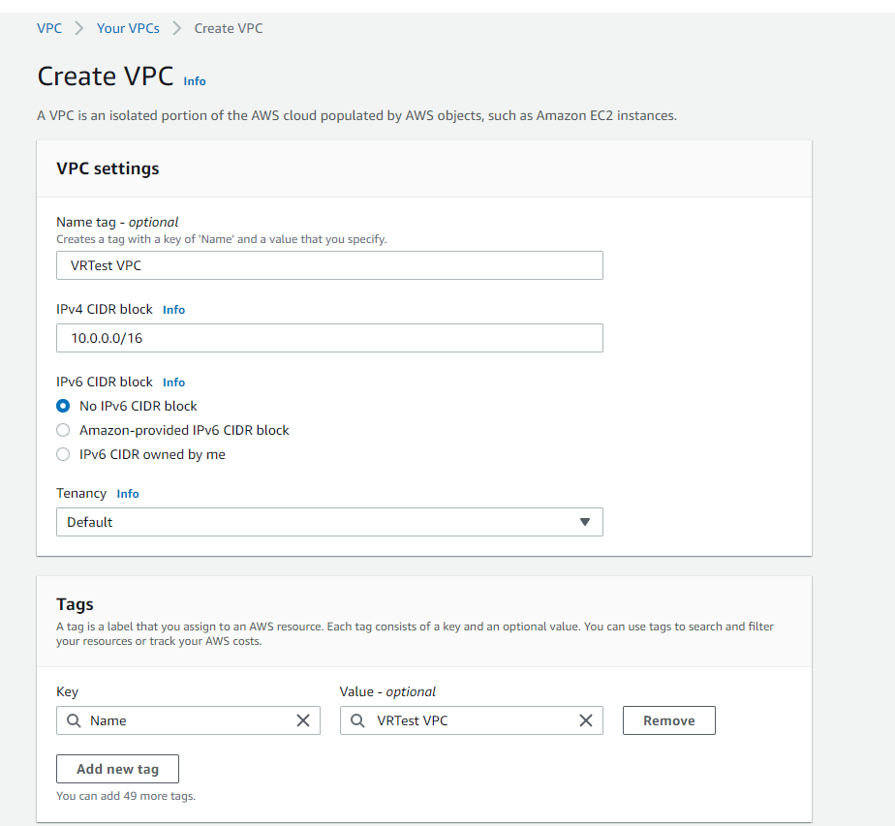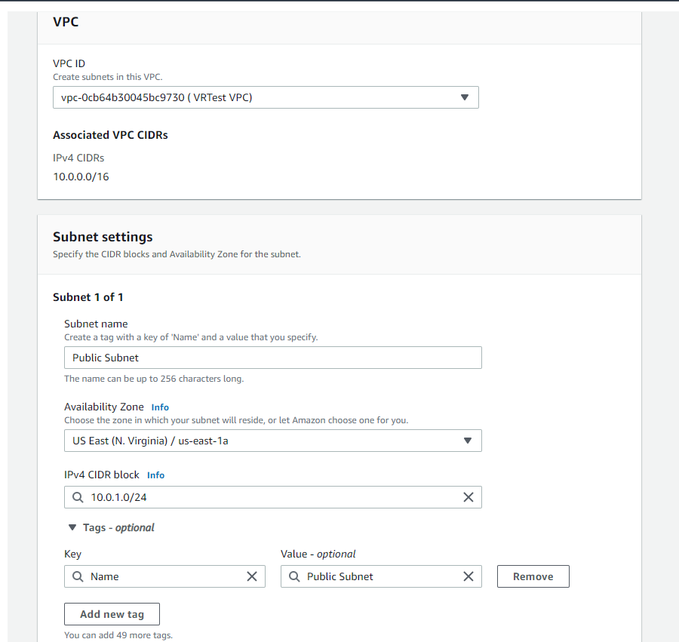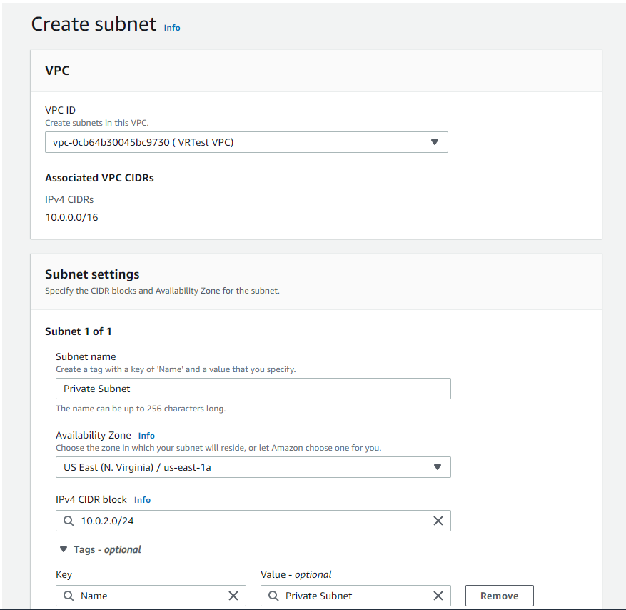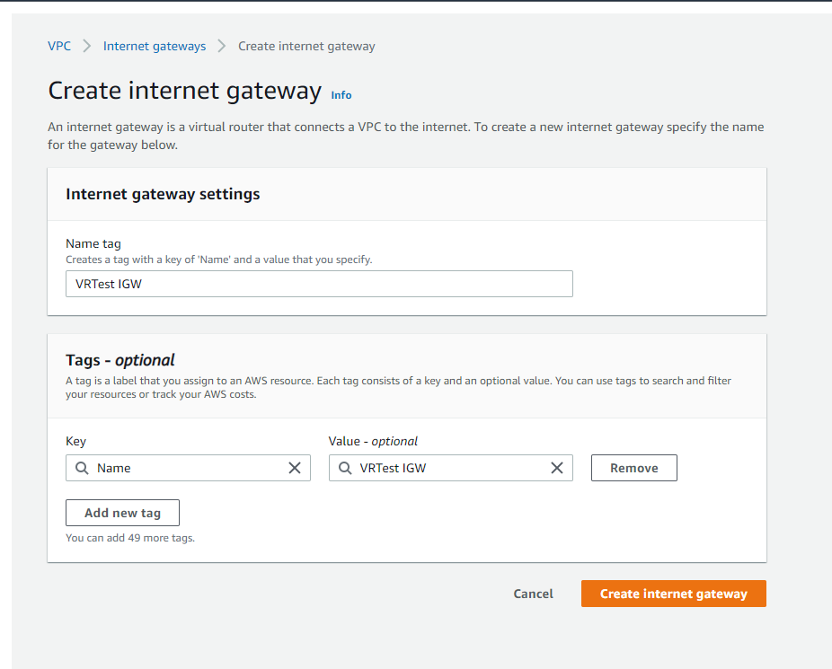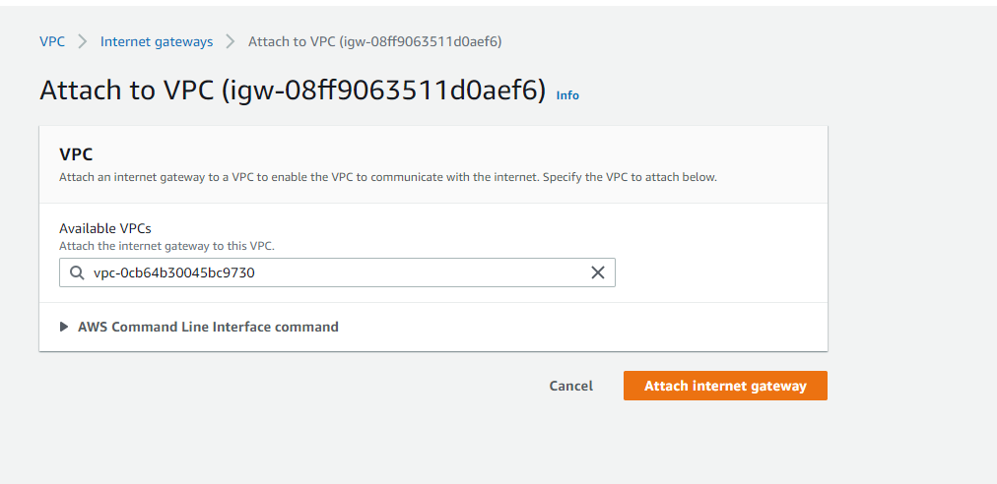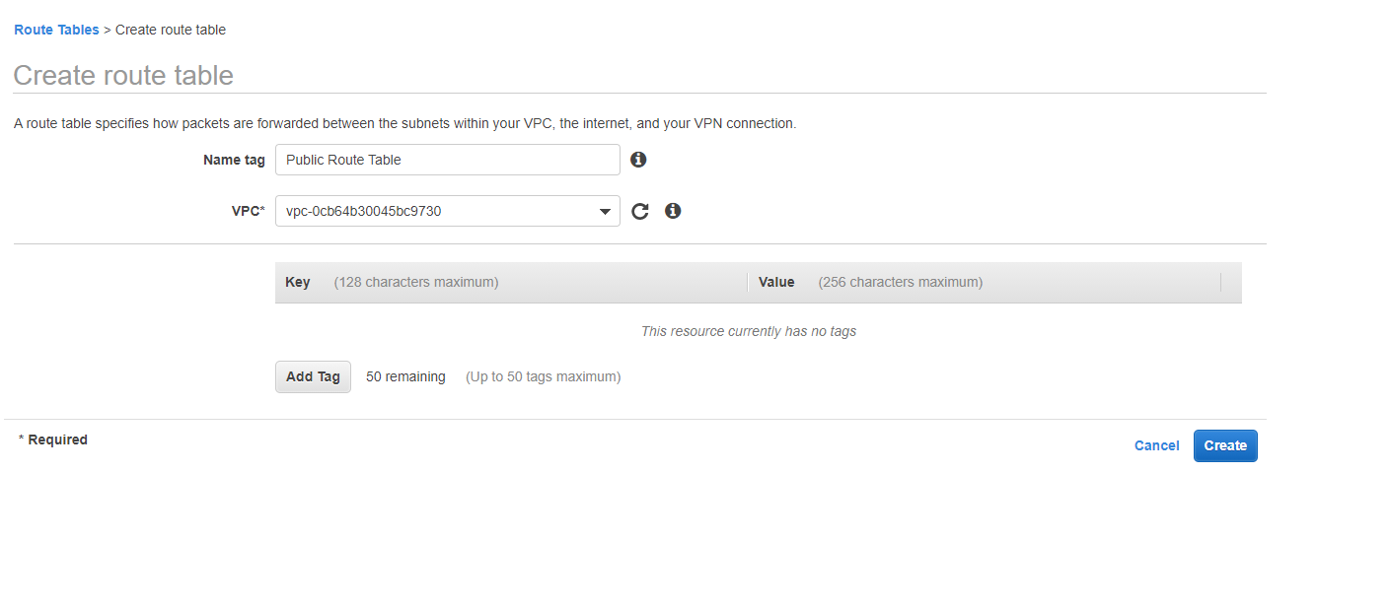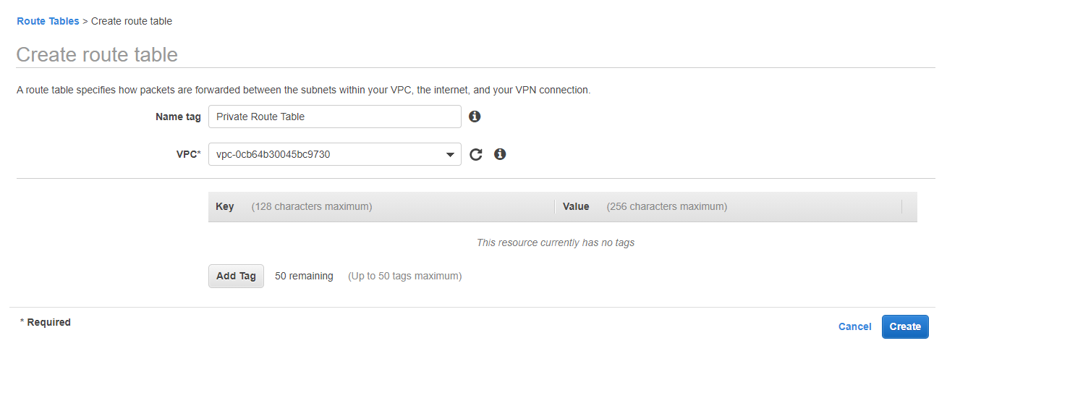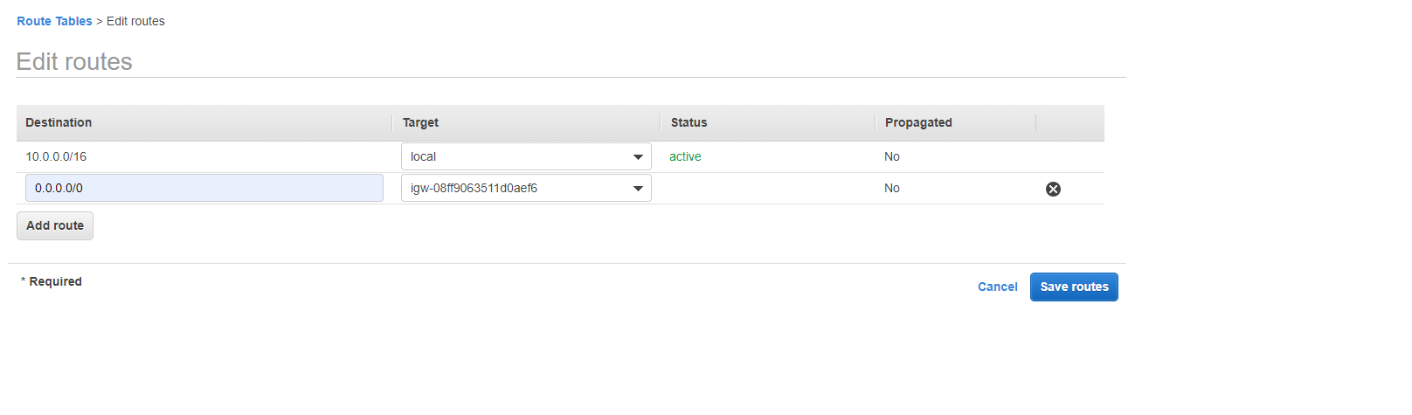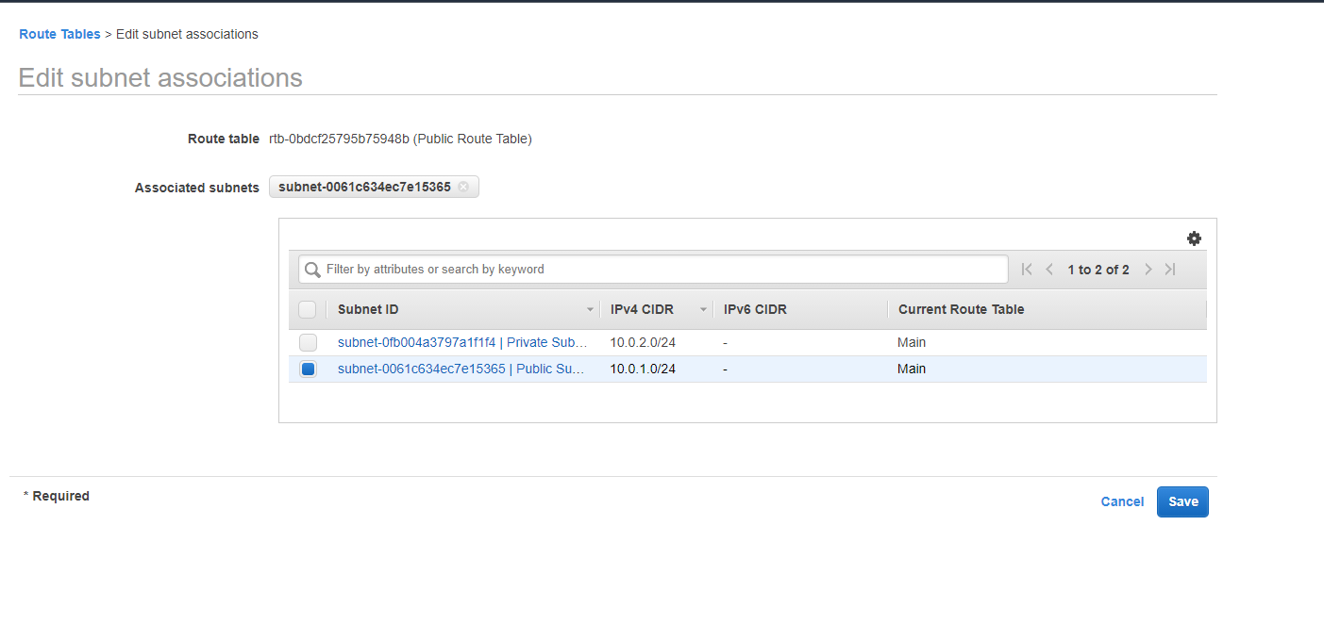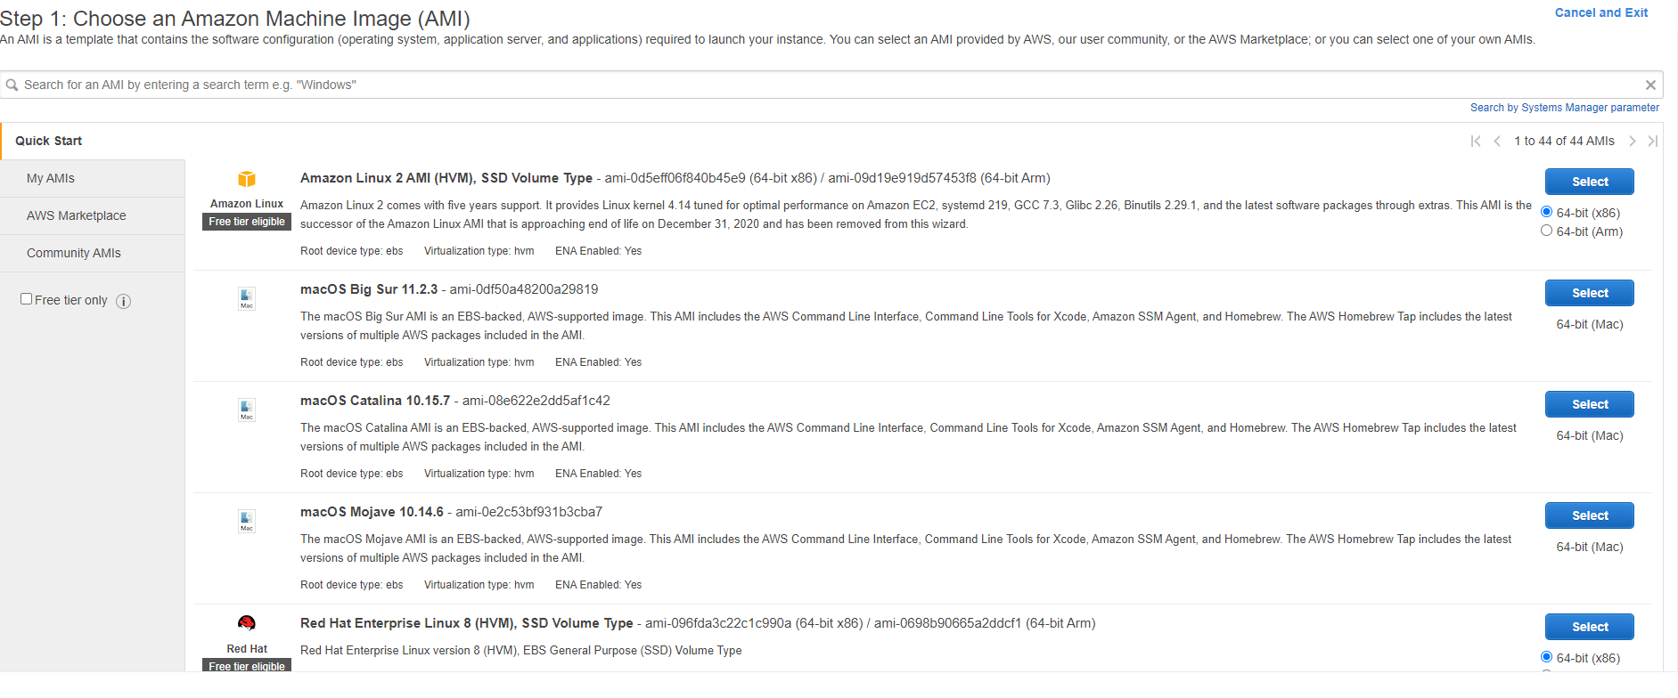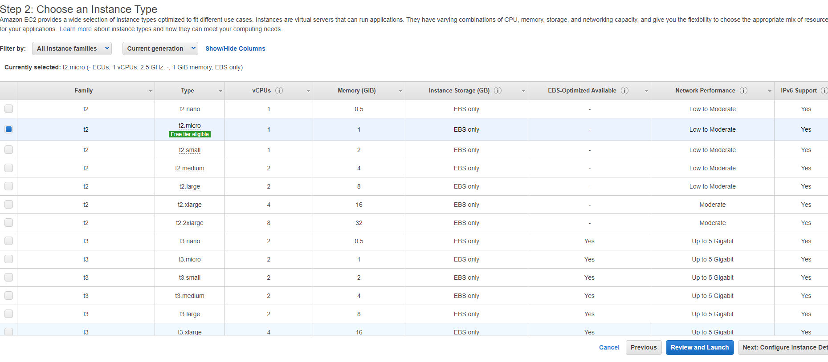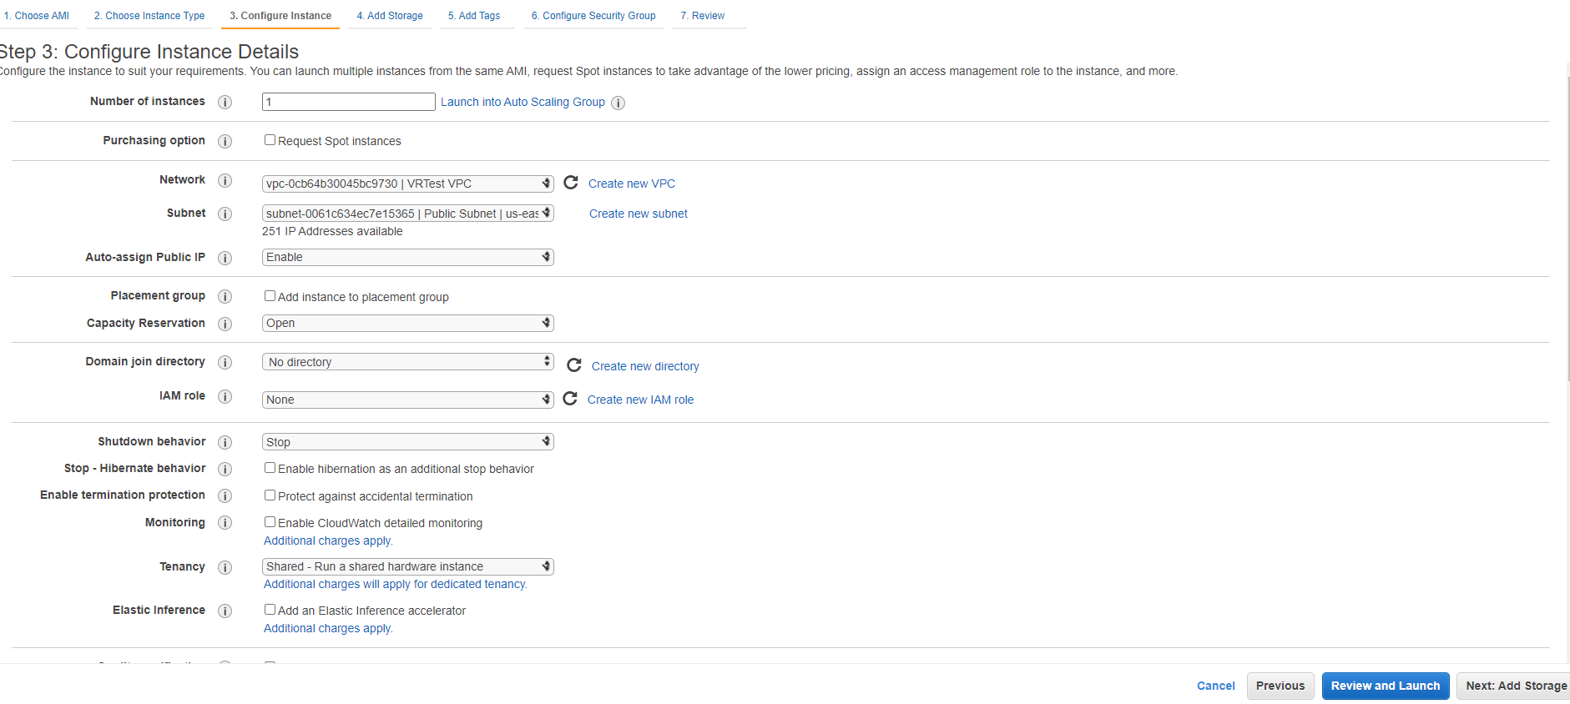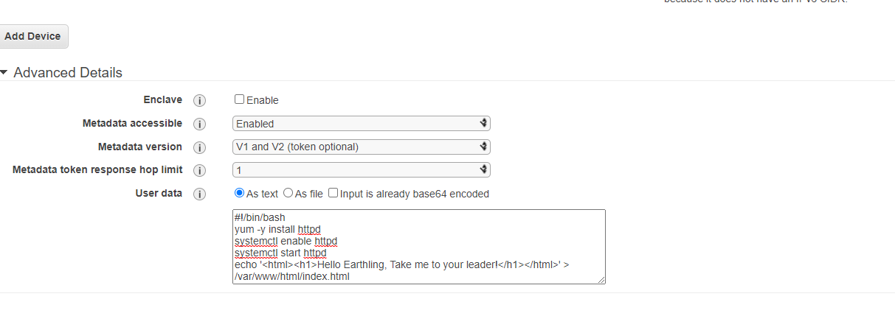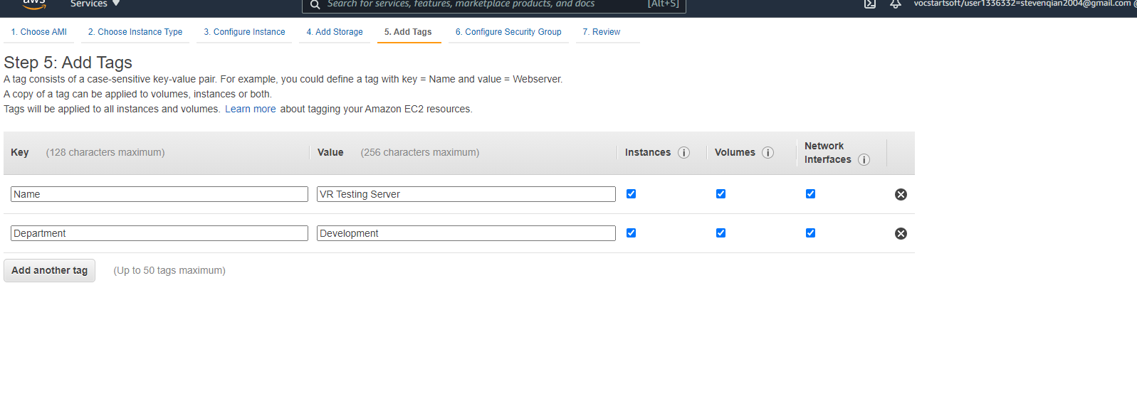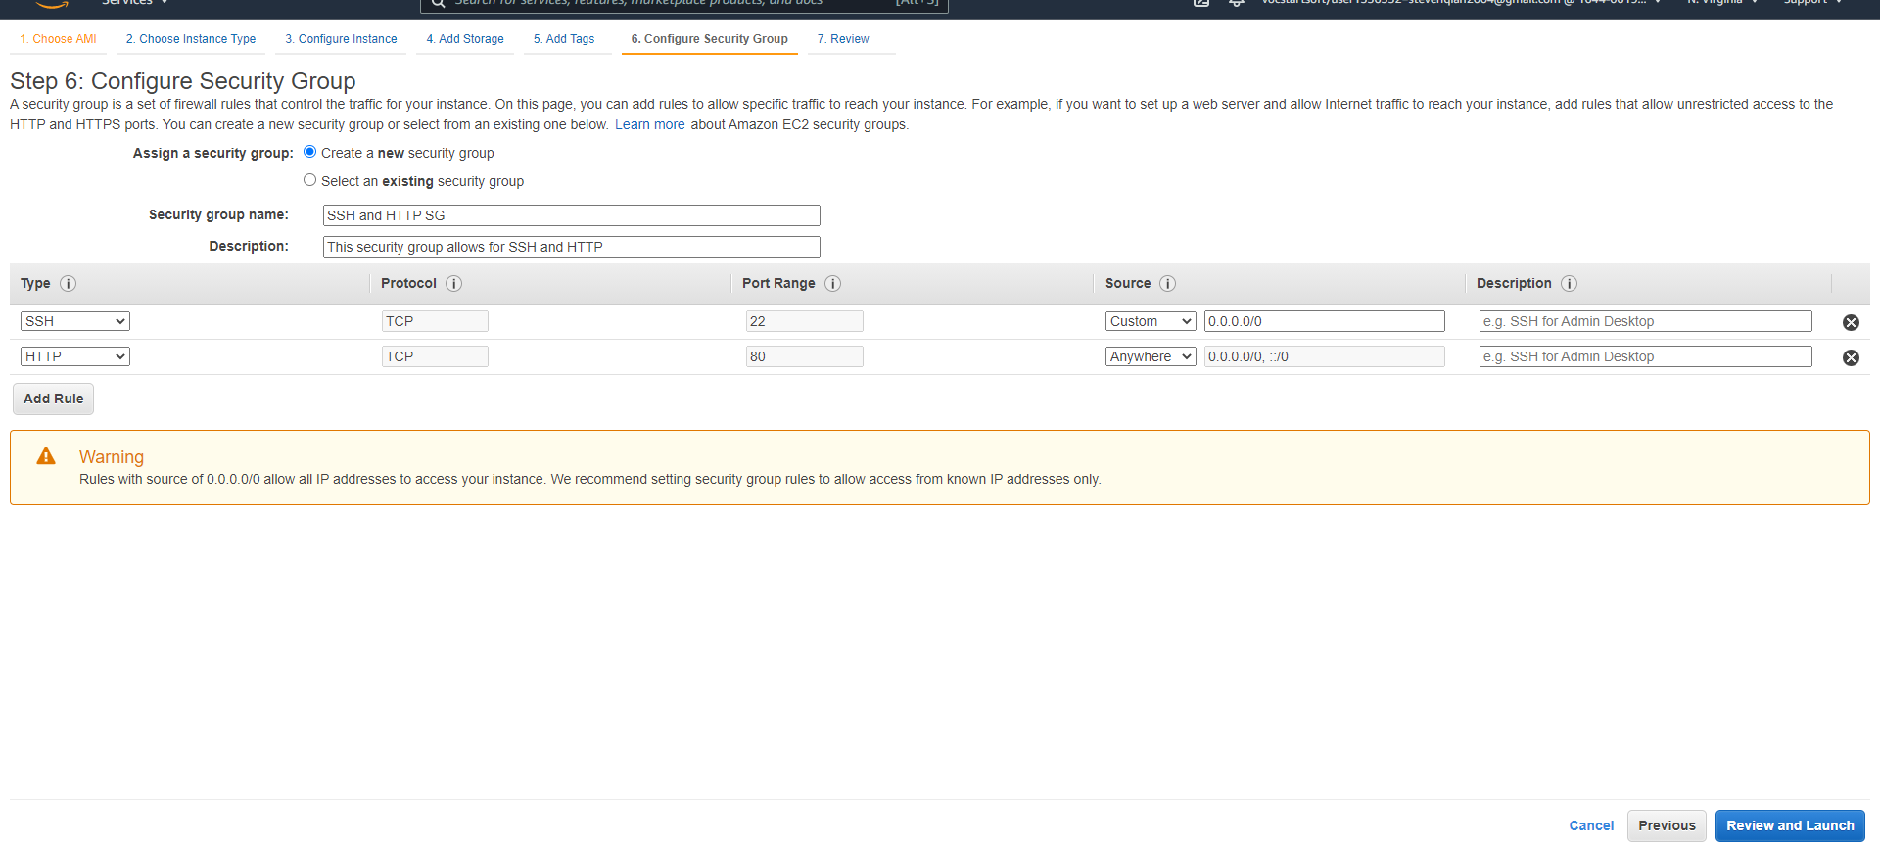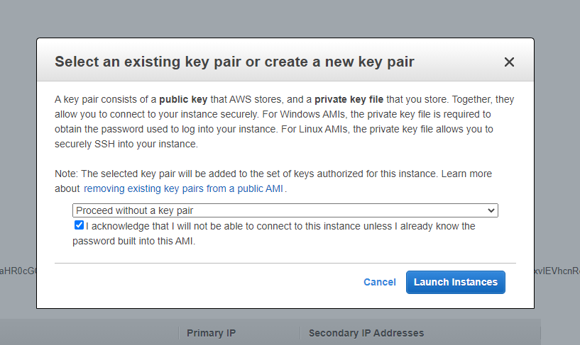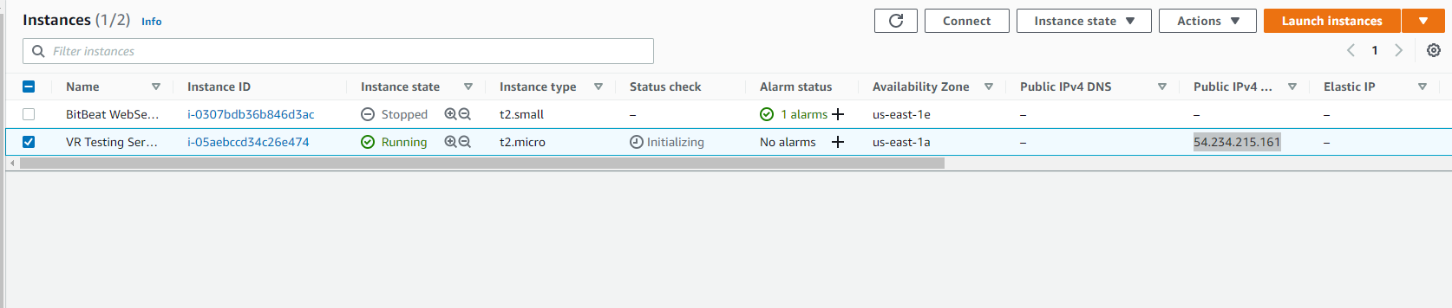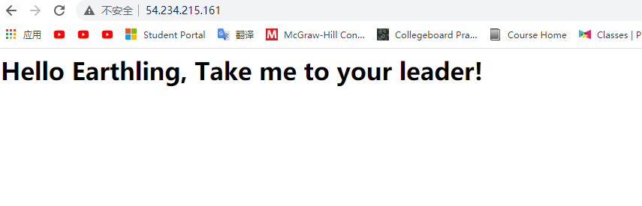

Questions

* Default VPC is a VPC that Amazon automatically creates for you in the account. It is set up so that you can run services such as EC2 that require a VPC without first creating a VPC.
* The public subnet is connected to the public route table.
* The instance uses default settings.
* The auto-assign public IP setting is disabled as default.
* The instance will not automatically assign public IP address.
* Security groups are virtual firewalls for instance. They protect your applications and data.
* A private subnet is a subnet that’s associated with a route table that does not connect to the internet via an internet gateway. You can use it when you have data that needs to be secured from the internet.
* Internet gateway connects your VPC with the internet. The VPC will not reach the internet without an internet gateway.